Yin-Jeh Tzeng 曾英傑

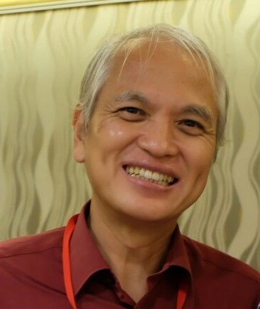
Department of Molecular Biology and Human Genetics
College of Life Science
Tzu-Chi University

No. 701 Zhongyang Rd., Sec. 3,
Hualien 97004, Taiwan
Tel: 886-3-8565301 ext 2671 or 2672
E-mail: tzeng@gms.tcu.edu.tw

- Education

Dr. rer. nat. 1997
Institut für Molekular Biologie und Biochemie, Freie Universität Berlin

- Present Position
1998 -Assistant Professor

- Publications
1. Tzeng, YJ., Guhl, E., Graessmann, M. & *Graessmann, A. (1993) “Breast Cancer Formation in Transgenic Animals Induced by the Whey Acidic Protein SV40 T- antigen (WAP-SV-T) hybrid gene” Oncogene 8, 1965-1971. (SCI)

2. Santarelli, R., Tzeng, YJ., Zimermann, C., Guhl, E. & *Graessmann, A. (1996) “SV40 T-antigen Induces Breast Cancer Formation with a High Efficiency in Lactating and Virgin WAP-SV-T Transgenic Animals but with a Low efficiency in Ovariectomized Animals” Oncogene 12, 495-505. (SCI)

3. Tzeng, YJ., Gottlob, K., Santarelli, R. & *Graessmann, A. (1996) “The SV40 T-antigen Induces Premature Apoptotic Mammary Gland Involution during Late Preganacy in Transgenic Mice” FEBES Letters 380, 215-218. (SCI)

4. Tzeng, YJ., Zimmermann, C., Gottlob, K., Guhl, E, Avantaggiati, M. L.& Graessmann, A. (1998) “SV40 T/t-antigen Induces Premature Mammary Gland Involution by Apoptosis and Select for p53 Missense Mutation” Oncogene 16,2103-2114 (SCI)

5. Goetz, F., Tzeng, YJ., Guhl, E., Merker, J., Graessmann, M. and *Graessmann, A. (2001) “The SV40 small t-antigen prevents mammary gland differentiation and induces breast cancer formation in transgenic mice; truncated large T-antigen molecules harboring the intact p53 and pRb binding region do not have this effect” Oncogene 20, 2325-32 (SCI)

6. Klein, A., Guhl, E., Tzeng, YJ., Fuhrhop, J., Levrero, M., Graessmann, M., and Graessmann, A. (2003) “HBX causes cyclin D1 overexpression and breast cancer formation in transgenic animals that are heterozygote for p53” Oncogene 22(19): 2910-9 (SCI)

7.曾英傑、傅淑玲 （2003）基因轉殖技術與RNAi效應、RCAS-TVA系統 （p.71~88）（教育部顧問室『生物技術科技教育改進計畫』專書：『動物基因轉殖技術與實驗』）

8. Klein A, Guhl E, Zollinger, Tzeng YJ, Wessel R, Hummel M, Graessmann M and Graessmann A （2005）”Gene expression profiling: cell cycle deregulation and aneuploidy do not cause breast cancer formation in WAP-SVT/t transgenic animals” J Mol. Med., 83: 362–376 (SCI)

9. Chang TW, Lin CY, Tzeng YJ, Lur HS. “Synergistic Combinations of Tanshinone IIA and Trans-resveratrol Toward Cisplatin-Comparable Cytotoxicity in HepG2 Human Hepatocellular Carcinoma Cells” (2014) Anticancer Res. 34(10):5473-80 (SCI)
D. Research Interests
1. The molecular biological formation of cancer
2. Phytochemical prevention of cancer
3. The roles of esters in development and cancer biology

